SANDMAN SECURITY
Triunfo Creek Vineyards Checkpoints

EVENT DETAILS (scan for timeline, important details, etc.)

EVENT PREP

1. Open Gate 2. Open Lockbox
[Go to Gate to Scan] [Go to Lockbox to Scan]

3. Spray Bug Fogger Before Vendor Arrival 4. Flag the Main Water Line

5. Pre-Event Cleaning Touch Up 6. Move TCV Furniture Requested (i.e. barrels)
(Likely already complete by TCV) (Rental company is contracted to do large items)

7. Check Lighting 8. Prep Restrooms & Trash
(Likely already complete by TCV) (Likely already complete by TCV)

9. Turn on Restroom Trailer 10. Turn on AC/Heat in Farmhouse
[Go to Restroom to Scan]

11. Open the Bar 12. Place TCV purchased wine in the bar refrigerator that says “for vendor use.” Click on event details at the top to view type & quantity. (Likely already complete by TCV)
[Go to Bar to Scan]

13. Turn on Small Fountain in Front of House

14. Make Sure Property Protection is Being Used 15. Smoking Section Setup
16. Turn on Outdoor Lights 17. Take MME of Photographers Card/Location Manager’s Card
DURING EVENT

1. Monitor Restrooms 2. Write in Total Guest Count (MME)
3. Turn On Creek Fountain 1 4. Turn On Creek Fountain 2
(These are set to a timer so they should automatically come on if there is water in the creek. Do manually if needed)
5. Log Decibels (at 8pm, 9pm, 10pm & 11pm) 6. Turn Off Speakers at Bar & Ceremony

7. Notify Gate Guard of Vendor Arrival Rules 8. Turn Off Outdoor Lights
POST EVENT
1. Make Sure Property Protection is Being Used 2. Ensure Vendors are Being Quiet

3. Put Away Sound System 4. Turn Off Restroom Trailer Water

5. Unplug Fountain 6. Hold Final Walk Thru (MME Violations)

7. Log Restroom % Full via MME 8. Turn Off Restroom Trailer Switches
[Go to Restroom to Scan]

9. Turn Off Creek Fountain 1 10. Turn Off Creek Fountain 2
(These are set to a timer so they should automatically turn off at 2am – Important to leave on during strike.)

11. Lock Up Bar, Storage & Farmhouse 12. Close Gate

[Go to Lockbox to Scan] [Go to Gate to Scan]

VENDOR ARRIVALS
Planner arrives/departs Rentals arrive/departs

Caterer arrives/departs Beverage arrives/departs
Florist arrives/departs Band or DJ arrives/departs
Valet arrives/departs Photographer arrives/departs
TCV CONTRACTED EXTRA FEES (If not part of client’s contract these need to be paid for on site or they will come out of the client’s security deposit – Sandman does not need to notify client of fees, just captures uses via MME and TCV will address post event)
Dumpster used ($300) Mule used ($175)
Barrels used ($40 each) Barrel coolers used ($50 each)
Fireplace used ($250) Heaters ($75 each)

Kitchen used (never for cooking – just storage/prep) ($125) Barbeque ($250)

Case/Bottles of Wine Purchased
Pricing & sales sheets in drawer under mirror in farmhouse
OR they can purchase thru PayPal at www.triunfocreek.com/wine (this is best)

APP INSTRUCTIONS
- Download free app from app store. App is called “QR-Patrol Live Guard Tour”
- Enter Guard ID & Pin
- Start Tour – Click to start your shift.

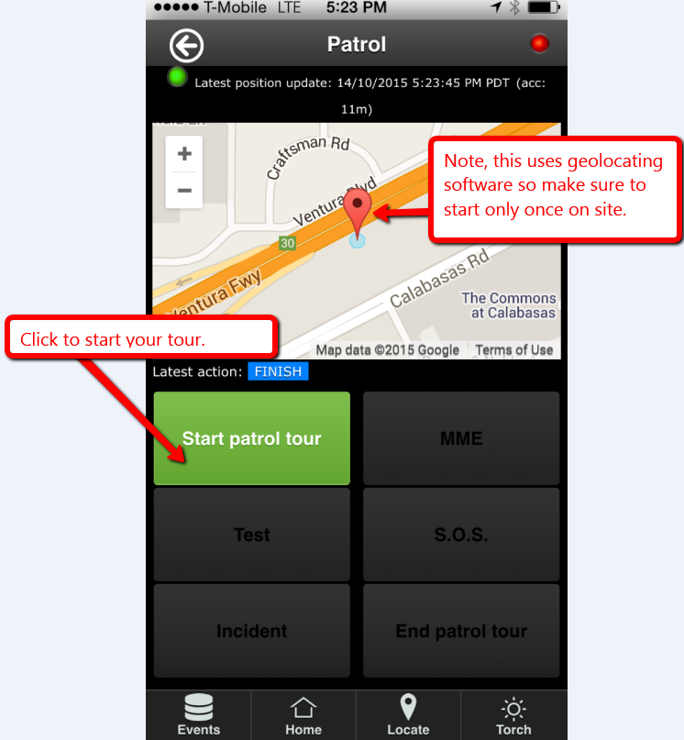

- Scan QR Code – Click on the green button to “Scan QR Code”

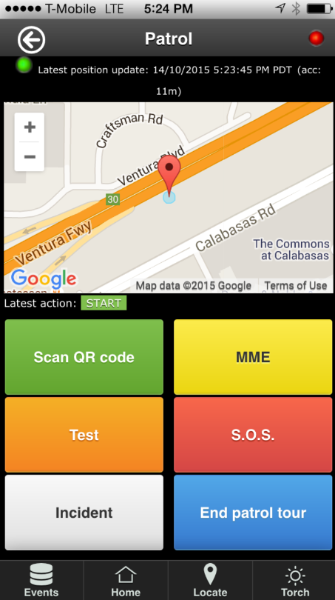

- Report an Incident
  - Click on the grey “Incident Button”
  - Check the incident type
  - Assign a location via scanning a QR code if applicable
  - Click “Send Incidents”

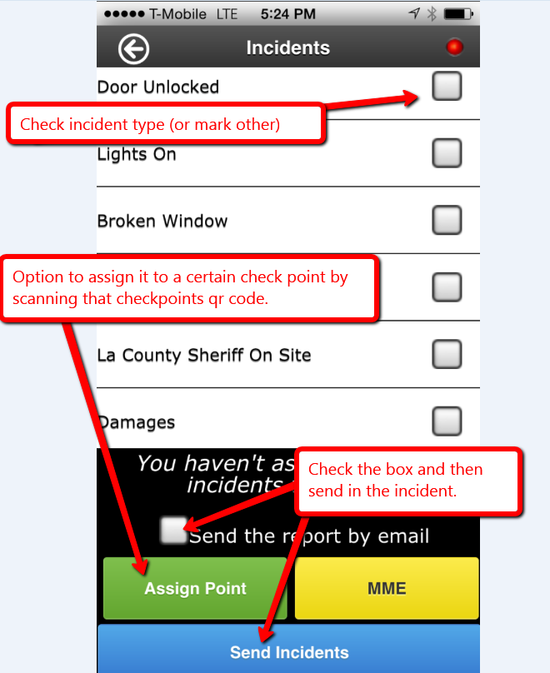

- Send MME
  - To log any images or video necessary click the yellow MME button
  - Then take the picture, video, or voice recording
  - Then click send MME

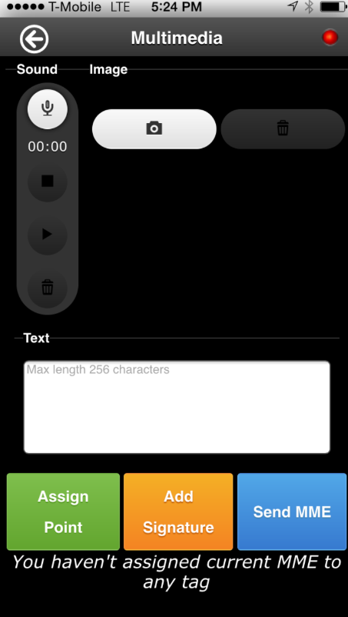

- End Tour – Click the blue end tour button.

OTHER IMPORTANT INFORMATION
Nothing can be left on the grass (watering begins at 2am).
If the load out isn’t complete before 2am put the sprinkler timer in the “Off” position and notify Jacqui 818.574.9999 (instructions on how to do this are in the site rep guide book).

HOW TO ADDRESS POTENTIAL NOISE COMPLAINTS
Note, if the LA County Sheriff is ever called for a noise complaint please call Jacqui and let her speak directly with the Sheriff (818.574.9999). If Jacqui is unreachable call Ray (818.653.6772).

Always get the Sheriff’s business card and contact info.

- Triunfo Creek Vineyards (TCV)/the Stewart/Lorenzen family is within its rights as land owners to host private events on site.
- TCV does monitor the decibels to make sure they are always at an appropriate level. If for any reason the Sheriff finds the noise level is too high we are more than happy to turn any music down.
- Our facility has an approved and permitted outdoor dance pavilion for these private events to take place. The approved permit is in the site rep guidebook. Please share this info with the Sheriff (Permit # 201400046/ Project # R2014-00120)
